**Mr. VED THAKUR**

THANE, THANE

Tel No : 9769252333 PIN No: 400603

PID NO: P132000092042

Age**:** 21.0 Year(s) Sex: Male

**Reference:**

Sample Collected At:

Thane pokhran cc mhl

Shop no 21 asiatic arcade,vartak nagar pokhran road no 1,thane w-400601. zone: c-19d(92)

**PROCESSING LOCATION:- Metropolis Healthcare Ltd, Unit No. 409- 416, 4th Floor, Commercial Building-1, Kohinoor Mall, Mumbai-70**

**VID: 1320050007415**

Registered On: 11/07/2022 05:05 PM

Collected On:

11/07/2022 5:05PM

Reported On: 12/07/2022 12:26 PM

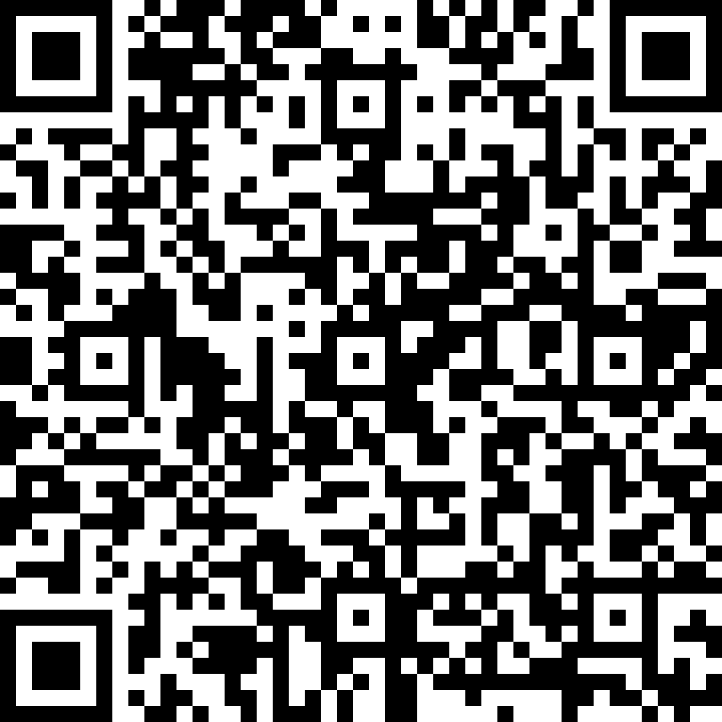

SARS-CoV-2 (COVID 19) Detection (Qualitative) by Real Time rt PCR*

**Test :** Qualitative RNA detection of SARS-CoV-2 (COVID19)

# Specimen Type : SWAB

**Test principle :** Real time reverse transcription PCR (ICMR approved kit)

**Test description :** Screening by “E” gene detection and Confirmation by

“RdRp , N or S” gene detection

# Result :

**NOT DETECTED**

**SARS-COV-2 RNA**

**ICMR guidelines do not recommend sole dependence on Ct Value for patient management.**

# The kit used for this SARS CoV 2 RT PCR test at Metropolis Healthcare ltd covers multiple targets and detects most of the possible mutations in current circulation such as UK strain, South african strain, Brazilian strain etc. however it may not be able to differentiate between them.

**We are sending such samples suspected of mutant strains which are recognised as significant to National influenza centre, Pune for further genome sequencing as per the guidelines issued by ICMR and state as well as local government bodies.**

# Metropolis lab ICMR registration no. METRO001 Interpretation guidelines

1. **For result as “DETECTED”:**
2. Detected result indicates presence of SARS-CoV-2.
3. Each “Detected” result has been verified using confirmatory test.
4. False positive is rare globally.
5. A repeat test of freshly collected specimen may give different result due to the following –
   1. From appearance of symptoms, Viral load reduces day by day and one may clear virus as early as 4.3 days¹. As viral load reduces during recovery/resolution, the result of repeat testing, even within hours or day/s, can yield different results.
   2. The new sample may have low viral load due to varied shedding of the virus.
   3. Inherent variability due to improper sample collection and inadequate storage while due care is taken at Metropolis.
6. 80% of patients with “Detected” result may be asymptomatic.
7. A detected result does not distinguish between a viable/replicating organism and a non-viable organism

**Mr. VED THAKUR**

THANE, THANE

Tel No : 9769252333 PIN No: 400603

PID NO: P132000092042

Age**:** 21.0 Year(s) Sex: Male

# For result as “NOT DETECTED”:

**Reference:**

Sample Collected At:

Thane pokhran cc mhl

Shop no 21 asiatic arcade,vartak nagar pokhran road no 1,thane w-400601. zone: c-19d(92)

**PROCESSING LOCATION:- Metropolis Healthcare Ltd, Unit No. 409- 416, 4th Floor, Commercial Building-1, Kohinoor Mall, Mumbai-70**

**VID: 1320050007415**

Registered On: 11/07/2022 05:05 PM

Collected On:

11/07/2022 5:05PM

Reported On: 12/07/2022 12:26 PM

1. “Not Detected” result indicates absence of SARS-CoV-2 in the given specimen. However, it does not rule out the infection completely and should not be used as the sole basis for making decisions related to treatment and other patient management decisions.



1. “Not detected” result may be seen due to -
   1. RT PCR done on Nasopharyngeal swab having 44% false negativity.
   2. Test done too early or too late where the virus load is below detection limit.
   3. Improperly collected and stored specimen.
   4. Viral mutations
2. If a subsequent test is tested positive (detected), it may indicate an infection acquired subsequently or increase in viral load to detectable level after the first test.

# Disclaimers:

1. RNA viruses like SARS-CoV-2 (COVID 19) have a lot of genetic variability and it’s possible that certain virus detection kits test cannot detect some strains of the viruses. Although efforts were made by manufacturers

of the diagnostic kits to design the test assays that target the parts of viral genome which are shared by all the different circulating viral strains, there still might be some mismatch between the primers and the probes used in the test and the target regions within the viruses.

1. Sensitivity of this test results depends upon the quality of the sample submitted for testing, stage of infection, type of the specimen collected for testing, medical history and clinical presentation.
2. All approved kits being used also may have different positive and negative predictive values leading to mismatch of results.
3. A careful consideration to combination of epidemiological factors, stage of infection, clinical history, examination, other relevant investigation findings and treatment history should be done when interpreting test results.
4. Current knowledge about novel coronaviruses is evolving and more studies may be required for further evaluation and review of facts indicated in this report.

# Patient Instructions:

* + Kindly consult referring Physician/ Authorized Govt. hospital for appropriate follow up.
  + Details of all the positive patients will be communicated to Epidemiology Cell whom you are requested to support.
  + “Detected” status needs to be notified to the appropriate authorities as per the existing rules/regulations, while we shall also be doing the same.

# Clinical Background:

COVID-19 is a new disease, caused by a novel (or new) coronavirus SARS-CoV-2. Reported illnesses have ranged from mild symptoms to severe illness and death for confirmed COVID-19 cases. Symptoms like Fever, Cough, and Shortness of breath may appear 2-14 days after exposure. The virus is thought to spread mainly from person-to-person, between people who are in close contact and through respiratory droplets. It can also spread from contact with infected surfaces or objects.

**Mr. VED THAKUR**

THANE, THANE

Tel No : 9769252333 PIN No: 400603

PID NO: P132000092042

Age**:** 21.0 Year(s) Sex: Male

# References:

**Reference:**

Sample Collected At:

Thane pokhran cc mhl

Shop no 21 asiatic arcade,vartak nagar pokhran road no 1,thane w-400601. zone: c-19d(92)

**PROCESSING LOCATION:- Metropolis Healthcare Ltd, Unit No. 409- 416, 4th Floor, Commercial Building-1, Kohinoor Mall, Mumbai-70**

**VID: 1320050007415**

Registered On: 11/07/2022 05:05 PM

Collected On:

11/07/2022 5:05PM

Reported On: 12/07/2022 12:26 PM

1. Tao Ai et al. Correlation of Chest CT and RT-PCR Testing in Coronavirus Disease2019 (COVID-19) in China: A Report of 1014 Cases



1. Yang et al. Evaluating the accuracy of different respiratory specimens in the laboratory diagnosis and monitoring the viral shedding of 2019-nCoV infections.

# Abbreviations

ICMR : Indian Council of Medical Research

# -- End of Report --